
TRI 2610 - CSP1123 MINI IT PROJECT
This document is in DRAFT mode and some minor details may change with time. Contact klpoh@mmu.edu.my with queries. Link to this document: https://bit.ly/2610mini
CLO1: Build a solution to simple IT problems using programming tools. (P3)
CLO2: Demonstrate effective communication in project work and a group presentation. (A3)
CLO3: Demonstrate self-learning and proactivity in a small, team-based software dev project. (A3)

OVERVIEW
This is a GROUP project consisting of mostly THREE (3) students per group.
You will develop a program from one of three development/software tracks. Submission will happen at the end of the trimester, but your assessment will be heavily influenced by timely updates in weekly progress updates.
Assessment will be based on the ability to produce a good program, proper group coordination through the usage of and reporting in modern project management tools for software development and project presentation.

TIMELINE FOR GROUPING AND SUPERVISOR SELECTION
Before trimester begins:
- Briefing in Tri 2530 final weeks.
  - Join the WhatsApp Group: (https://chat.whatsapp.com/Dw5OLHIFNjoInEYqN2LzIE)
  - Reference for ClickUp & Kanban/Scrum
- Students form groups of THREE (3).
  - Remaining students who are unable to form groups of 3 may be allowed to work on the project as pairs. Solo work is NOT POSSIBLE and NOT ALLOWED.
  - Use this form: https://forms.gle/jGq1yfJ4z8Q8XsqH6
- Students are invited to a platform called ProPro to propose topics to their supervisors.
  - We will use this student-built platform ProPro to share with you the supervisor capacity live and as a method to submit proposals to your supervisor.
  - You will be invited AFTER you’ve formed your group.
- Students propose topics to potential supervisors for approval.
  - Each supervisor will have suggested topics. You may choose one of their topics and modify/add some details or you may propose your own topic to them.
  - You must submit a proposal to a lecturer and obtain approval for the lecturer to be your group’s supervisor. You are encouraged to contact (email or meet) and discuss with the lecturer before proposing to increase your chances of being accepted.
- Once a lecturer approves your proposal, that lecturer is now the supervisor for your project. You do not have to do anything during the holidays other than getting your topics approved.
Once trimester begins:
- Week 1 – workshop on Git and GitHub.
  - Reference for Git & GitHub
- Week 2 – finish setting up ClickUp (add supervisor as admin, and name it as 2610 CSP1123 GXXX), GitHub (make sure publicly accessible) and complete Market Research.
- Week 3-14 – weekly meetings with supervisors. Arrange with your supervisor the timing of your weekly meetings. 9 of these meetings will be compulsory and scored.

NOTE ON WORK DIVISION AND TEAM COMMUNICATION
- Remember that when coming up with your work division, every group member is required to code. As this project will require you to use Git tracking from week to week, supervisors will be able to see in detail your contribution to the code base over time.
- Different group members are allowed to have varying levels of coding-related work however, as you may need to assign tasks which are not coding related. Preparing assets (sound/graphics) for games, designing game systems, mocking up site design, developing a database, conducting market research, etc. These activities should be tracked in ClickUp.
- Your coordination work should be visible to your supervisor via ClickUp. If you have physical discussions or online discussions via WhatsApp, minutes/notes/screenshots/etc of those discussions should be recorded in ClickUp for everyone’s reference.
- More on Git and ClickUp in “Software Project Tools” section later.

DEVELOPMENT TRACKS
For your project, choose one of these three tracks and a language/framework based on what is available from your supervisors. Not all supervisors will take all three tracks.
Track: | Web Application | Desktop Application | Game
Recommended language / framework: | Python/Flask  Python/Django | Python/Tkinter  Python/QtPy | Python/Pygame
Other language / frameworks: | Ruby/Rails  PHP/Laravel | C++/Qt  Dart/Flutter on Desktop | GDScript & C#/Godot  C#/Unity  C++/Unreal Engine
Since all of you have learned Python in a previous course, it is the language you are strongly recommended to choose. It is the language that your supervisor is most likely to be able to offer you advice/assistance with.
However, some of you may wish to take on an additional challenge to do additional self-learning for other languages or platforms. Consult with your potential supervisors if they will accept a project in your preferred language/platform. However, please make the decision and commit to it AS A GROUP. Do not choose a language/platform because one of you is familiar with it as that one person cannot and should not be doing all the coding work. Choose it only if all of you are willing to commit to learn it.
The following examples are here to give you an example of how to write scope only – do not choose from this list. Refer to lecturer proposed topics or come up with your own ideas (see later section on Brainstorming Ideas). All proposals are subject to lecturer approval.

WEB APPLICATION TRACK
In this track, build a web application that solves a problem/provides functionality for a specific purpose. Many of the applications here will carry the concept of CRUD– the Creation, Reading (viewing), Updating and Deleting of various things like users, items, records, etc using a web interface accessing a database. Examples of application ideas under this track:
- MCQ Quiz System
  - Users – create, delete, login, logout, change password
  - Quiz (Teacher) – create, delete, edit, view
  - Quiz Questions (Teacher) – create, delete, edit, view
  - Quiz (Student) – view (take quiz), submit, view attempts/results
  - Extra – quiz navigation, results during/end of quiz, question bank with randomisation.
- Campus Friends (Halal Tinder for MMU)
  - Users – create, delete, login, logout, change password
  - Friend recommendation/matching
  - Profiles – upload image, edit profile, view profile, search
  - Chat – send/view message, send images
  - Admin – report profile, ban profile
- E-Commerce System
  - Users – create, delete, login, logout, change password
  - Customer – view items, shopping cart, checkout
  - Admin – add, remove, update, delete, view items/stock
  - Extra – recommendation system, search, etc
Remember that some desktop style applications can be built on the web as well, however, engage your supervisor in discussion to ensure that you have sufficient breadth/depth of features for your scores.

DESKTOP APPLICATION TRACK
In this track, build a desktop application that solves a problem/provides functionality for a specific purpose. Desktop applications typically provide very specific functionality for productivity, communication, or entertainment. To avoid overly simplistic desktop apps, make sure your app works with data and do some kind of calculation or data display/manipulation.
Examples of application ideas under this track:
- Pomodoro Helper
  - Pomodoro Timer – timer (25 mins) with breaks (5 mins) x 4, set category/set task
  - Sound – background music with selection, alarm sound with selection
  - Tracker – recent productivity/task/usage data, category/usage visualisation
  - Extra – App in taskbar, overlay window with timer/controls, configurable pomodoro settings, other gamification features
- Palworld Game Helper (adapt idea to any data heavy game)
  - Pal database – view, search by name, search/sort by attributes
  - Breeding calculator – calculate probability of getting X passive skill if male/female parents have X passive skills, how to get child pal from parent pal, etc.
  - IV (internal value) estimator – calculate IV from pal’s level, stats, and passive skills
  - Extra – Element weakness chart/recommender, pal + 10 catch tracker, pal builds
- Dungeons and Dragons 5E Tools
  - Dice Roller – D2, D4, D6, D10, D12, D20, D100 dice roller (with animation?)
  - Character Sheet – save/edit fields in character sheet with nice presentation
  - DM Tools – encounter tracker, turn tracker, item/monster database
  - Data – import/export character sheet, save more than one character sheet.
  - Extra – Character sheet skins/options/layouts, character creation process, roll dice with modifiers (attack, skills, etc)
Remember that you can build CRUD-based applications like the web application track examples on desktop as well. You will then store the data into a local database (like SQLite).

GAME TRACK
In this track, build a desktop game that is… fun. ;) In the game track, you can choose to be system heavy (build many systems or very complex systems, with one or two examples of story, combat, stages etc) or content heavy (few/simple systems, but complete story or content from level 1 till max level, with many different environments, characters, stages, etc).
Try to pick games where you can work on different subsystems simultaneously. (E.g. Member A can develop an empty world with moving dangers and build many stages. At the same time, member B can develop a character’s movement and add attack skills on a simple flat stage.)
Examples of games suitable under this track:
- 2D Side-scrolling Platformer
  - World/environment – open/scrolling world or stage/levels, surfaces (moving?), environmental threats, puzzles.
  - Character Movement – character movement options and skills, animations.
  - Mobs – NPCs in the story, enemies with different movement
  - Either (or both)
    - Combat – character/mob combat options and skills, animations.
    - Story – interface elements like dialogue, cutscenes, dialogue options to tell a story.
  - Extra – base building, resource gathering, crafting, management, automation.
- 2D Turn-based RPG Game
  - World/environment – (move player from encounter to encounter) 2D world map with movement or clickable map with visitable locations or daily life cycle with choices
  - Story encounter – characters, dialogue, dialogue choices, animations
  - Combat encounter – characters, character stats, action choices, animations, action results
  - Extra – inventory, one-use/equip-able items, bosses, branching storylines.
- Idle game (e.g. cookie clicker)
  - Currency – main currency, manually earn currency (click, key press), purchase/upgrade automatic currency earners.
  - Minigame 1 – win a small minigame to get big time limited boost.
  - Minigame 2 – win a small minigame to get a small but permanent boost.
  - Save and load game.
  - Extra – ascension (reset to zero and restart with special bonuses), active play strategy vs passive play strategy, extra mini games.
- Simulation/management game
  - Resource screen –harvest/gather ingredients (e.g. pots plant seeds)
  - Craft screen – combine ingredients into products (e.g. brew potions with plants)
  - Sell screen – put up products for sell, customer thought bubbles (e.g. potion shop)
  - Extra – market trends to impact popularity of product types, upgrades for resource/craft/sell systems, crafting minigames, 2D store with character movement, store profit/loss charts.
Games banned under this track:
- All variations of flappy bird (character moving towards obstacles or obstacles moving towards character with keys to avoid)
- All variations of pong, space invaders, snake game, tic-tac-toe and common board games – basically basic game tutorials you can’t add much content/customisation to.
- Maze games.
- Your lecturer may decide to reject proposals which are too similar to existing games/tutorials.
Remember that you can build a RESTful web-based game as well (check out the concept of asynchronous games), but it will fall under this track as the focus would not be on CRUD.

SAMPLE PROJECTS
- 2410 Projects (ignore warning about unsafe link)
- 2420 Projects
- 2510 Projects

BRAINSTORMING IDEAS
Although a basic project will still be sufficient to demonstrate your ability to execute a project at the Foundation level, you are strongly encouraged to come up with a certain level of originality for your problems and solutions. This helps you score higher, and it also helps your lecturers differentiate your work from the numerous online tutorials and resources. Copying programs wholesale from tutorials does not help you learn much.
Differentiating your project can come in the form of:
- Building an app targeted at a very small group or very local users (MMU students/staff) with features/information that applies only here. (MMU subjects, locations, clubs, events, facilities, etc etc. Cyberjaya locations, facilities.)
- Solving your own very specific problems. What weird workflow/need you always had that you wished could be solved in an app - build that.
- (Apps) Visit https://arstechnica.com, skim through 50 articles of tech news quickly and see all the weird technology related news for inspiration.
- (Apps) Visit https://play.google.com, browse to the least common categories and see if anything inspires you.
- (Games) Find weird mechanics and themes. "World moves only when the character moves." "Move the 'world' instead of the character." "All weapons are kids' toys."
- (Games) Google "Game Jams" and see the themes they use. "Roles reversed" for example - be the worm on a fishing hook instead of the fisherman catching the worm.
- (Games) Visit https://www.rockpapershotgun.com, skim through 50 articles quickly and see all the games and the features/themes they cover for inspiration.

SOFTWARE PROJECT TOOLS
You will be assessed not only on your final submitted program, but also on the process which you use to get there. Your lecturer will observe these through your written team communications. In modern software project teams, two common tools are often employed. You will use these tools to gain early familiarity with how the industry conducts its business.

CLICKUP
ClickUp is our tool of choice for project/feature management. Every group is required to create a workspace for their group on ClickUp for project management and team communication. (https://app.clickup.com/)
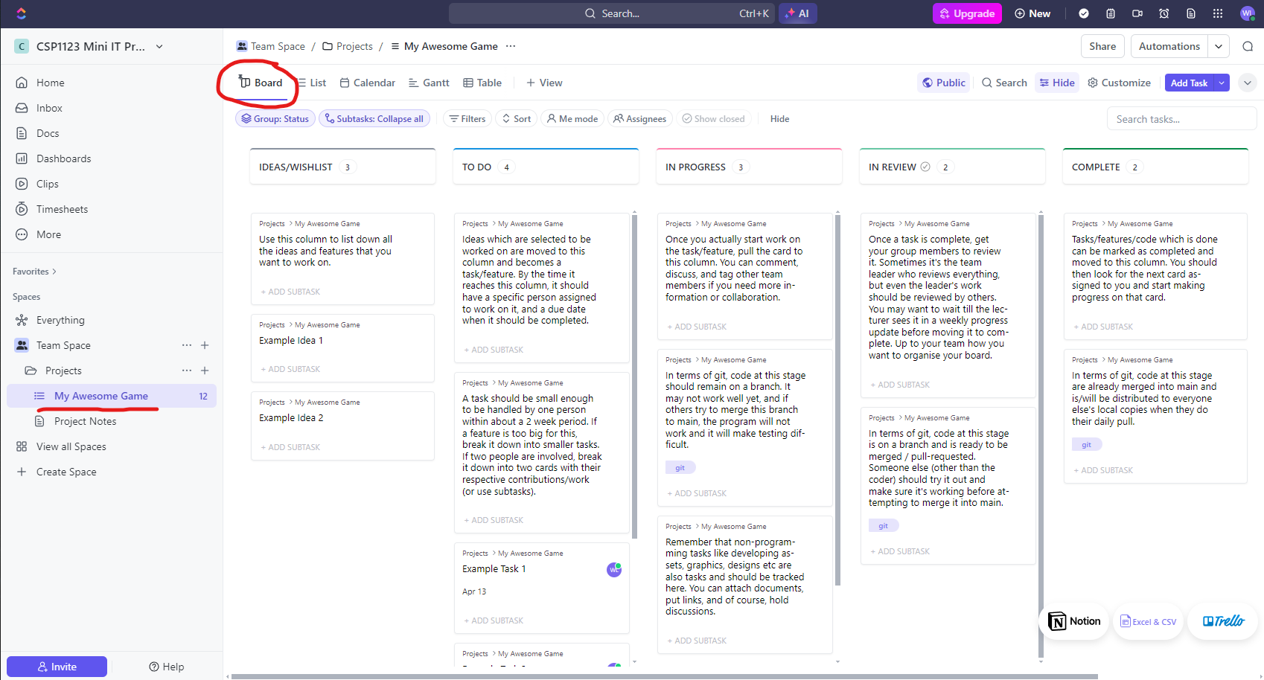
You may structure your ClickUp based on the template at this link. Each group is required to have a ClickUp board, and you will present your weekly progress from this board. Any progress not reported/recorded in detail on this board will not be considered.
Use the kanban board in ClickUp to:
- Plan your features, work division and internal deadlines.
- Hold documents/doc links detailing detailed design documents like flow charts, game design, combat stats in Excel or Google Sheets.
- Track progress/issues on feature development.
- Collaborate/discuss details about your project.
- Record/declare your references/sources/ai generation usage to avoid any misunderstandings in assessment.
- Record notes from physical meetings or other online discussions.

GIT
Your group is required to use Git (https://git-scm.com/) and GitHub (https://github.com/) for version control as you work on your code throughout the trimester. Each project must have a GitHub repository that is updated whenever there is code progress. Commit to git every 15-30 minutes or so of coding. Push to GitHub approximately once a day. Merge code contributions between different group members every week. We will explore how to use this tool further in the initial briefing. Any progress (even if you can demo it) not committed to GitHub will not be considered.
Note: Asset files (sound/image/video) change less often compared to source code. Since they are not text files, we also cannot meaningfully track changes in them using Git. If you have large numbers of them, they should not be stored in your Git repository. These should be shared to your teammates via traditional file sharing channels like OneDrive/Google Drive.

WEEKLY PROGRESS
Apart from the initial briefing, there will be no content-based lectures/tutorials for this subject. In their place you will be having weekly progress meetings with your lecturer. In these sessions you will:
- Present your task progress and overall completion rate via your ClickUp board.
  - No slides will be allowed. Any documents you wish to show should be attached to your ClickUp cards.
  - In the ClickUp cards, note down items you wish to discuss – problems encountered, questions for your lecturer, and make sure to note down any feedback given by your lecturer in the cards as well.
- Demo the current state of your program via your computer.
  - For convenience, make sure that your laptop can connect via HDMI dongle to the projector as that is what is available in most labs.
  - Any code you demo MUST be committed to GitHub or it will be ignored, and your progress will be marked unsatisfactory.
  - You may be asked to explain some of your code and tested on code authenticity during your weekly progress. (See section on Individual Modifier rubrics later)
- You will be scored on a scale of “Excellent, Satisfactory, Unsatisfactory, No Progress”.
Consider the weekly progress meetings as an integral part of your assessment. DO NOT surprise your supervisor in the final week with last minute work. Your final presentation should consist of things which your supervisor has seen before in weekly progress meetings, with perhaps a few minor finishing touches.

DELIVERABLES & SUBMISSION
- All deadlines are as of 11.59 pm on the Saturday of that week.
- Before Week 1 – Group Formation (via Google Forms – link in Page 1)
- Before Week 1 – Topic Proposal (via ProPro for students with groups)
- Week 2 – Add your Supervisor to your ClickUp as Admin. Ensure GitHub is publicly accessible.
- Week 2 – Submit ClickUp and GitHub link (comment in ProPro in your approved project)
- Weeks 3-14 – Weekly Progress with Supervisors (9 meetings will be assessed/rated.)
- Week 14 – Final Source Code Submission – submit to eBwise assignment
- Week 15 (Study Week) – Presentation with Demo and Interview with Supervisor and Moderator

MARKET RESEARCH
After proposing your project conduct market research on similar existing software/games. In this market research you should:
- Identify similar software/games available in the market (or through tutorials). You should pick popular/well-known options if possible. (Look at three different programs if possible, if not, do a more in depth review of two.) For each software/game:
  - Identify the features available in it.
  - Identify the strengths and weaknesses of the software (so that you can compare the different programs)
- Example market research at this link.
Create a card titled “Market Research” and write your market research directly in the description of the card – format it using Markdown. Use this market research to help you design the features that your own project should have. You should aim to be different from other similar programs.

FINAL SOURCE CODE SUBMISSION
You are required to submit the source code and assets for your project. Although your GitHub will already contain your source code, your asset files will need to be organised properly together with it:
- First, create a folder with your group name. For example: Grp05
- Place your deliverables in this folder, complete with folder organisation.
- Compress the folder as a ZIP archive. This will keep the folder structure inside intact.
- Double check your ZIP archive before submitting. Transfer it to another computer, unzip it and test to see if the program still runs. DO THIS EARLY to avoid running into last minute problems.
Your submission must not exceed 100 MB in size.
Due to the wide variety of program types and frameworks we are allowing, your supervisor and moderator will likely be checking your work during your Presentation and Demo session (through your computer). However, your source code should be organised and ready for execution in case we need to do any follow up checks.

PRESENTATION WITH DEMO AND INTERVIEW
Presentations will be held in Week 15 (Study Week). Each group is to present/demo your project for a maximum of 12 minutes. You may give a brief introduction but focus on the software itself. You can discuss your rationale/design decisions while demonstrating your product.
After the presentation/demo your group will be interviewed on your code contributions for approximately 8-10 minutes total. Interview questions are meant for INDIVIDUALS. When your supervisor or moderator directs a question to a specific group member, do not assist that group member in answering the question or he/she will not receive any marks.

ASSESSMENT
Your assessment is divided as follows. More details are in the rubrics below.
Component | Marks | Remarks | Scored By | CLO
Reporting | 30 | Group Marks with Individual modifier | Supervisor | 2
Weekly Progress | 10 | Group Marks with Individual modifier | Supervisor | 3
Presentation | 10 | Individual | Supervisor & Moderator | 2
Implementation | 50 | Group Marks with Individual modifier | Supervisor & Moderator | 1

PENALTIES:
- Penalty of 1 mark for each day of late submission
- We will give ZERO (0) marks to students who plagiarise AND to students who intentionally or unintentionally help other students plagiarise by giving all or some of their code.

PLAGIARISM & AI CODE ASSISTANTS
It is normal to seek help from friends or online resources when you are working on your project. However, there are limits to this. For the purposes of this project, plagiarism means the following:
- Turning in work that, from the examiner’s point of view, you do not sufficiently understand.
- Turning in other’s work (whether partly or fully) as your own/without crediting the source.
- Turning in code which is copied wholesale off a tutorial online.
- Turning in code generated from AI code generators that you do not understand, or you have not refactored/integrated into your own project.
Notice that this is not a complete ban from the usage of tutorials or ai generation. What is the right way to use these resources when trying to learn for your project?
- State your references/sources/ai generation usage clearly if you are relying on a reference when developing features – note them down in your ClickUp cards. There is no shame in acknowledging learning – if learning has actually occurred.
- Complete a tutorial and learn the components it teaches you. For example, how to draw buttons/objects on the screen/page. How to animate objects. How to make buttons behave a certain way. Take these components and implement it as your own logic into your program.
- Ask an AI code generator for an example of how a certain routine or function may be written. Understand and test that code and then try to modify/rewrite it to fit your own project.
- Ask an AI code generator to help fix a bug you cannot find, or to answer questions whether certain features are possible or easy/hard. Remember that AI does not always get things right!
Throughout these 14 weeks, you should be interacting very often with your supervisor about your project. By submission time it should be very clear that you’ve built the program of your own unless you do not take your weekly progress updates seriously. Do not make it difficult for the supervisor to understand how you have come to learn the skills you claim to have learned by the end of the semester. Declare your process clearly so that it is easy to trust you. It is not the supervisor’s job to find proof that you have learned. It is YOUR job to prove to the supervisor that you have learned.
What about assets, images, sounds, game systems etc:
- You are ALLOWED to use free images/graphics/game assets in the building of your program. You can of course draw your own if you wish. Of course, curating/selecting assets is not as difficult as coming up with your own. DO NOT just reproduce a website/screen design in its entirety. DO NOT use copyrighted assets. Instead look for assets licensed under Creative Commons or MIT License, or other permissive licenses.
- You're allowed to reproduce existing mechanics and systems. This is obvious with apps - like ticketing or booking or e-commerce systems. None of these are new ideas. With games you can 'reproduce Pokemon's elemental weakness system' in your own turn-based 2D game, for example. HOWEVER, the word 'reproduce' contains the word 'produce' - i.e. YOU are building it. As mentioned, copying a tutorial for an e-commerce site or a platformer IS NOT YOUR OWN WORK. As such, when you propose ideas, google up the keywords in your ideas, and consider every tutorial that comes up as a threat to your credibility. Differentiate yourself in terms of features or demonstrate VERY CLEARLY how you independently built yours.

INDIVIDUAL MODIFIER
Your individual final marks based will be calculated as follows:
$Individual Final Score=Presentation+$
$\left(Reporting+Weekly Progress+Implementation\right)×\frac{Individual Modifier }{12}$
Do note that although Reporting, Weekly Progress and Implementation is marked as a group, you will each receive differentiated scores depending on your individual contributions based on the rubric below.
Criteria | 4 – 100% of Group | 3 – 75% of Group | 2 – 50% of Group | 1 – 25% of Group
ClickUp | Contributed more than card status with active participation (commenting and tagging) in ClickUp. | Contributed more than card status in ClickUp. | Only tracked card status in ClickUp. | No meaningful participation in ClickUp.
GitHub | At least 1 ÷ (2 × No. of Group Members) of contribution in Git. | Between 1 ÷ (2 × No. of Group Members) and 1 ÷ (2.5 × No. of Group Members) of contribution in Git. | Less than 1 ÷ (2.5 × No. of Group Members) of contribution in Git. | Did not own code contributions via Git, or cannot track lines contributed in Git.
Own Work | Student able to answer all interview questions. There is no doubt in the lecturer’s mind that the program is the student’s own work. | Student unable to answer some interview questions. There are segments of the program the student is unable to explain. | Student unable to answer most interview questions. Student unable to explain many parts of the program. | Student unable to provide even a general idea of how the program works, program is clearly not student’s own significant effort.
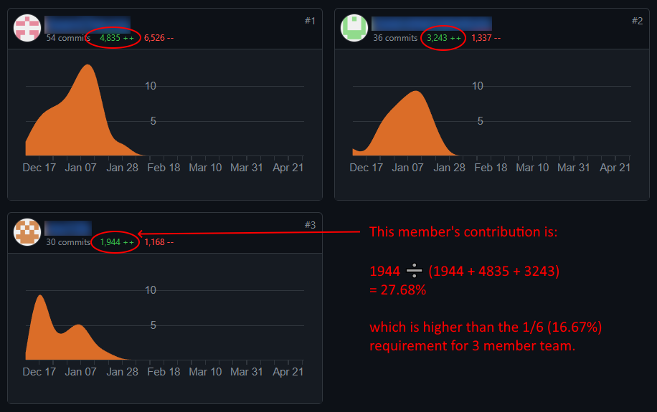
If your GitHub contribution screen is not functioning at the end of the trimester due to abnormal Git and GitHub usage, the supervisor will try to estimate lines contributed based on the user (email address) that committed each line in the final codebase through Git commands.

REPORTING (30%)
The group will be marked based on the rubric below. Reporting score formula:
$Reporting Score=\frac{Reporting Rubric Score}{16}×30$
Criteria | 4 – Exceeding | 3 – Meets | 2 – Approaching | 1 – Does Not Meet
Market Research | More than two programs with similar features are considered, exploring their strengths and weaknesses and possible improvements. Deep discussion and analysis on market positioning. | Two programs with similar features are considered, exploring their strengths and weaknesses and possible improvements. | Two programs with similar features are considered with limited discussion on their strengths and weaknesses and possible improvements. | Less than two programs are considered, or programs considered are not relevant. Limited discussion on programs’ strengths and weaknesses.
Project Planning | More than four cards per student in ClickUp, or sub-tasks are used. Every card is assigned to the individual person in charge, with a reasonable deadline. Cards represent a reasonable portion of tasks / features of the project. | At least four cards per student in ClickUp. Every card is assigned to the individual person in charge, with a reasonable deadline. Cards represent a reasonable portion of tasks / features of the project. | Less than four cards per student in ClickUp. Some cards are missing deadlines. Many cards are assigned to multiple people, causing confusion on the role / task of each individual. Cards do not accurately represent tasks / features of the project. | ClickUp cards are not updated with details on deadline or person assigned. Cards do not represent tasks / features of the project.
Team Comm in ClickUp | ClickUp card descriptions are detailed out with the feature being built. Design documents and images are uploaded and shared. Team members comment on cards and tag each other to discuss details and share information. | ClickUp card descriptions are detailed out with the feature being built. Design documents and images are uploaded and shared. | ClickUp card descriptions contain some details of planning but used inconsistently. | ClickUp cards are not updated with any details (title only).
Git Usage | Code is committed to git regularly with regular merges. Students work on and push code using branches. Code is merged to main branch using pull requests on GitHub. | Code is committed to git regularly with regular merges. Students work on and push code using branches. | Git tracking is present but commits happen in large chunks or through file uploads. | Git tracking is not used.

WEEKLY PROGRESS (10%) (GROUP)
The group will be marked based on the rubric below. Reporting score formula:
$Weekly Progress Score=\frac{ Weekly Progress Rubric Score}{4}×10$

FINAL RUBRIC
The final group marks for Weekly Progress is based on this rubric. The ratings mentioned here is based on the weekly rubric.
Criteria | 4 – Exceeding | 3 – Meets | 2 – Approaching | 1 – Does Not Meet
Weekly Progress | At least two ‘excellent’ updates. At most two ‘unsatisfactory’ updates. No ‘no progress’ updates. | At most two ‘unsatisfactory’ or ‘no progress’ updates. | At most three ‘unsatisfactory’ or ‘no progress’ updates. Of these, at most two ‘no progress’ updates. | More than three ‘unsatisfactory’ or ‘no progress’ updates, or more than two ‘no progress’ updates.

WEEKLY RUBRIC
During every weekly progress, the group shall be scored using the rubric below:
Criteria | 4 - Excellent | 3 - Satisfactory | 2 - Unsatisfactory | 1 - No Progress
Weekly Progress | Students completed more than a week’s worth of features as planned in ClickUp timeline,  or  project is ahead of schedule with room for additional features or polish to project. | Students completed a week’s worth of features as planned in ClickUp timeline,  or  project is on track as estimated based on number of features to be completed by project end. | Students completed less than a week’s worth of features as planned in ClickUp timeline,  and  project is possibly not on track as estimated based on number of features to be completed by project end. | Students barely completed any work that contributes to meaningful progress for project.

PRESENTATION (10%) (INDIVIDUAL)
The student will be marked based on the rubric below. Presentation score formula:
$Presentation Score=\frac{Average Supervisor \& Moderator Rubric Score}{8}×10$
Criteria | 4 – Exceeding | 3 – Meets | 2 – Approaching | 1 – Does Not Meet
Elocution | Confident and fluent delivery with appropriate speech rate and volume. Tone and pitch modulated to emphasise ideas and create interest. Excellent articulation. | Fluent delivery with appropriate speech rate and volume, with tone and pitch sometimes modulated to emphasise ideas and create interest. Good articulation. | Smooth delivery in most places. Use of tone and pitch can be improved, with speech occasionally a little fast, slow, loud or soft. Adequate articulation. | Delivery halts in many places. Delivery is monotonous, or speech is too fast, slow, loud or soft. Poor articulation.
Engagement | Has regular eye contact, establishes engagement with the audience. Looks away only a few times throughout the whole delivery. Facial expressions and body language generate strong interest and enthusiasm. | Has adequate eye contact, establishes engagement with the audience. Looks at reference once every few sentences. Facial expressions and body language sometimes generate interest and enthusiasm. | Has some eye contact, establishes limited engagement with the audience. Looks at reference after every other sentence. Facial expressions and body language are used to try to generate enthusiasm but are somewhat faked. | Has very little eye contact, establishes no engagement with the audience. Reads straight from reference. Very little use of facial expressions or body language. Did not generate much interest in topic being presented.

IMPLEMENTATION (50%)
The group will be marked based on the rubric below. Implementation score formula:
$Implementation Score=\frac{Average Supervisor \& Moderator Rubric Score}{28}×50$
Criteria | 4 – Exceeding | 3 – Meets | 2 – Approaching | 1 – Does Not Meet
Scope | Successfully implemented all proposed functionality. Scope of project involves more than one major functionality for each group member. Web app / desktop app / game is released, functional and available for end users. | Successfully implemented most proposed functionality. Scope of project involves one major functionality for each group member. | Attempts to implement most proposed functionality. Scope of project involves one major functionality for each group member. | Attempts to implement some proposed functionality. Scope of project involves less than one major functionality for each group member.
 | One major functionality here refers to a complete function like “image upload and sharing” or “game environment” or “customisable timer”, etc. For releases, students are encouraged to find free options. Web apps should be hosted online (e.g. PythonAnywhere or Heroku), desktop app and games should be released in binary form. (e.g. GitHub Releases for apps & Itch.io for games.) Use your GitHub repo’s README.md to provide the link to the release.
Difficulty | Meets Level 3 requirements. Shows significant additional work through usage of complex data structures / algorithms, or advanced libraries to provide additional functionality (e.g. image manipulation, file conversion, minimax algorithm, etc.) | Student applied knowledge in coding (variables selection, repetition, arrays and functions) while employing major libraries or frameworks to provide program flow with GUI. | Student applied knowledge in coding (variables selection, repetition, arrays and functions). while employing some minor libraries only. | Student only applied knowledge in coding (variables selection, repetition, arrays and functions), producing a console-only application.
Complexity | Pages/screens change dynamically depending on data or user input. Program visualises data or processes data into meaningful information. Proper file/data storage methods are employed, and program involves a robust database.  Games: Animations (if relevant) are employed effectively. Game systems are deep and complex (no way a human can keep up with variables.) | Pages/screens change dynamically depending on data or user input. Proper file/data storage methods are employed.  Games: Animations (if relevant) are employed. Game systems are sufficiently complex (a human would barely be able to keep up with variables.) | Pages/screens change dynamically depending on data or user input.  Games: Animations (if relevant) are employed in a few places. Game systems are simple (a human can easily keep up with variables.) | Static pages / screens only.  Games: Animations (if relevant) are not employed. Game systems are so simple user input is not meaningful.
Usability / Purpose | The program is an original and effective solution to an interesting real-life problem. Or, the game excites the user / is funny / has a ‘wow’ factor. | The program is usable and fulfils its stated purpose. Or, most of the game is fun and entertaining. | The program is usable. It addresses some of its stated purpose. Or, some parts of the game are fun. | The program is unusable or does not address its stated purpose. Or, the game is mostly not fun.
User Interface | User interface is beautifully designed and responds to user behaviour. Results of user actions is clear. User experience is smooth, meaningful and logical. User does not get lost while using program. | User interface is functional and logical. Results of user actions is clear. User experience is acceptable. User seldom gets lost while using program. | User interface functional, some aspects can be confusing. Results of user action is sometimes unclear. User experience can be improved. User sometimes gets lost while using program. | User interface dysfunctional in many places. Results of user action often unclear. Program is difficult to use. User often becomes lost while using program.
Error Free Execution | The program runs without errors. Students highlight how most possible input and behaviour are accounted for. | The program runs with minor errors with input or behaviour which does not disrupt program flow. | The program runs with some errors that disrupt program flow, but user is still able to use the full extent of the program. | Errors make the program unusable and disallow the user from using the full extent of the program.
Code Organisation | Naming convention and comments sufficiently makes the code easy to read throughout. Source code files and folders have sensible naming and organisation. Irrelevant files are not committed to git. | Naming convention and comments sufficiently makes the code easy to read throughout. Source code files and folders have sensible naming. | Naming convention and comments are used in critical segments of code, but there is some confusion in other segments of code. | Naming convention and comments are poorly used leading to difficult to read code.

